Supplemental information for

Insight into the mechanism of different substituents on the zinc oxo cluster in the solubility switch

*Fang-Ling Yang1, Zong-Biao Ye1*, Dong-Xu Yang2,* *Yu-Qi Chen1, Pan-Pan Zhou3, Fu-Jun Gou1\**

1Key Laboratory of Radiation Physics and Technology, Ministry of Education, Institute of Nuclear Science and Technology, Sichuan University, No. 24 South Section 1, Yihuan Road, 610065, Chengdu, People’s Republic of China

2State Key Laboratory of Optical Technologies on Nano-Fabrication and Micro-Engineering, Institute of Optics and Electronics, Chinese Academy of Sciences, Box 350, Shuangliu, 610209, Chengdu, People’s Republic of China

3State Key Laboratory of Applied Organic Chemistry, Key Laboratory of Nonferrous Metal Chemistry and Resources Utilization of Gansu Province, College of Chemistry and Chemical Engineering, Lanzhou University, No. 222 South Tianshui Road, 730000, Lanzhou, People’s Republic of China

**KEYWORDS:** Extreme Ultraviolet Lithography (EUVL), Zinc-oxo cluster, Reaction mechanism, Density Functional Theory (DFT)

**Python code for calculation of RMSD:**

from openbabel import openbabel

import glob

def calculate_rmsd(file1, file2):

obConversion = openbabel.OBConversion()

obConversion.SetInAndOutFormats("xyz", "xyz")

mol1 = openbabel.OBMol()

mol2 = openbabel.OBMol()

obConversion.ReadFile(mol1, file1)

obConversion.ReadFile(mol2, file2)

aligner = openbabel.OBAlign(True, False)

aligner.SetRefMol(mol1)

aligner.SetTargetMol(mol2)

if aligner.Align():

rmsd = aligner.GetRMSD()

return rmsd

else:

raise ValueError("Alignment failed.")

xyz_files = glob.glob("*tor.xyz")

file_list = [i.replace(".xyz","") for i in xyz_files]

print(file_list)

for i in file_list:

file1 = i + ".xyz"

file2 = "Zn_2-4p.xyz"

try:

rmsd_value = calculate_rmsd(file1, file2)

print(f"The RMSD value between the two molecules is: {rmsd_value:.4f}")

with open("rmsd.txt", "a") as f:

f.write(i + "\n" + str(rmsd_value) + "\n")

except Exception as e:

print(f"An error occurred: {e}")

Obtaining the ionization potential (IP) using the following formula:

VIP = EN-1 – EN

AIP = EN-1, opt – EN

where VIP and AIP represent vertical and adiabat ionization potential, respectively. EN is the single point energy of neutral molecule. EN-1, opt and EN-1 are the single point energies of cations with and without optimization. The cation was obtained by removing an electron from the corresponding neutral molecule.

The spin density of all structures was calculated using Multiwfn software and shown in Fig. 1. The structures were derived from their corresponding neutral molecules with one electron removed, without further optimization. The organic ligand would lead to a significant difference in the ionization site, which is located on the carbon-carbon sigma bond in the TFA and terminal C=C bonds in MA ligands.

Fig. S1 Diagram of spin density for structure with different ligands after ionization. Isovalue = 0.002 a.u..

As depicted in Fig. 2, the geometry's deformation between after and before ionization can be evaluated using Root Mean Square Deviation (RMSD). Zn(MA)6 has the lowest RMSD value of 0.03 Å, indicating that the ionization causes small deformation in this composition. However, geometry would be significantly different when a high percentage of trifluoromethyl (-CF3) remains on the structure, suggesting that the structure after ionization is closely related to the type of organic ligands. The difference in structure before and after ionization would derive from the site of ionization changes.

Fig. S2 The structural difference between relaxed and unrelaxed after ionization based on the structures with minimal energy. The green geometrical configuration represents unrelaxed structure. The relaxed configurations were labeled blue. The number (used red font) at the corner of each picture represents the corresponding RMSD value, and the unit is Å.

The different free radicals add to Zn(MA)3(TFA)3_a and Zn(MA)4(TFA)2_a to yield thermodynamically stable complexes.

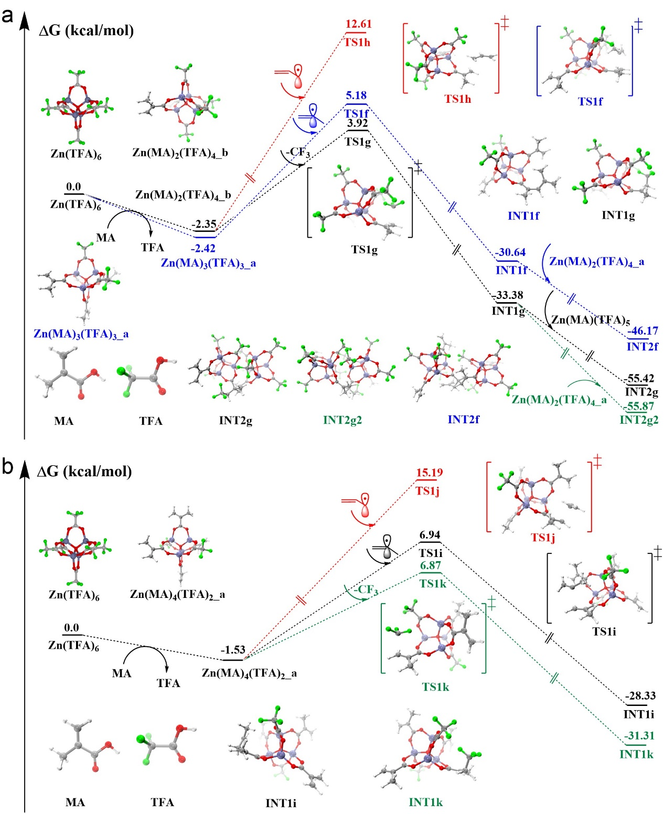

Fig. S3 The energy profile of chain propagation for (a) Zn(MA)3(TFA)3_a and (b) Zn(MA)4(TFA)2_a.

Obtaining the twisting energy (ETE) using the following formula:

ETE = ETS – Eoriginal

where Eoriginal is the single point energy of the minimal energy structure in the initial state. ETS is the single point energy of the corresponding fragment in the transition state. ETE could evaluate the deformation of fragments during the reaction process. The deformation usually increases the energy of the system.

The results of molecular dynamics at different temperatures. The red font in a picture is the mean value of bond length (between two specified atoms) in run time.

Zn(TFA)6

300 K

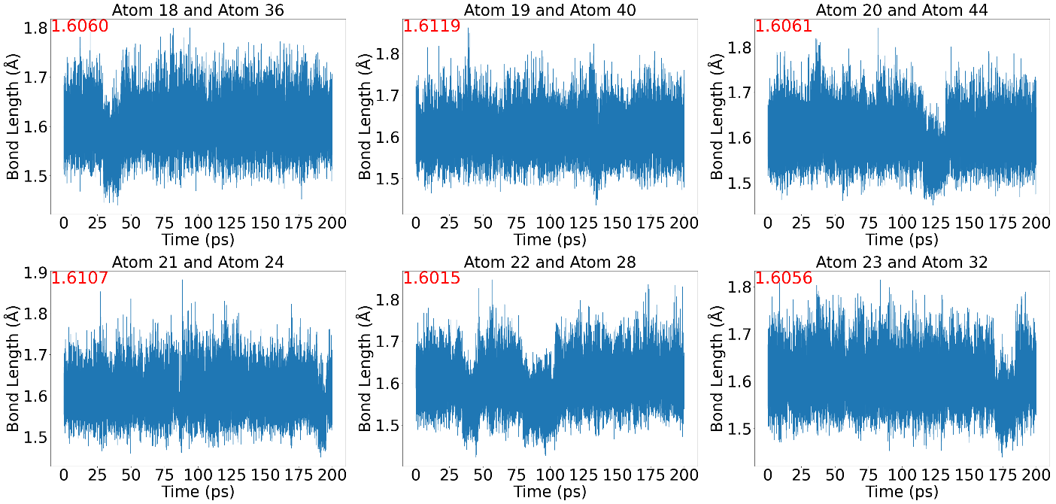

400 K

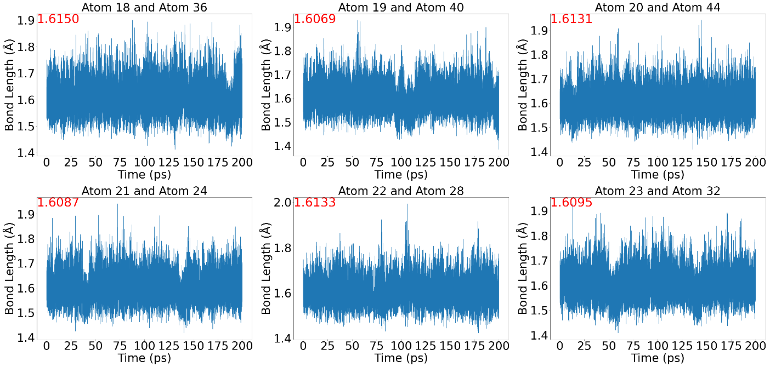

500 K

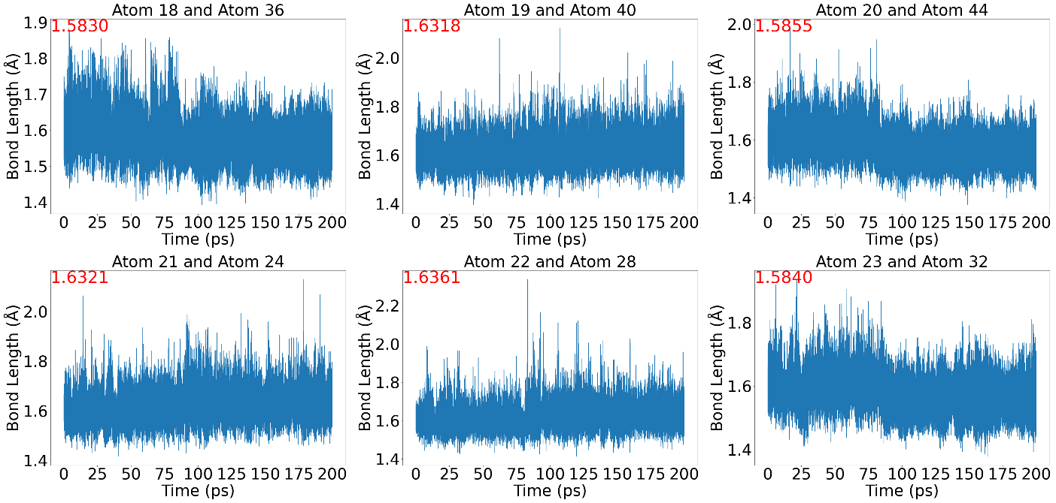

600 K

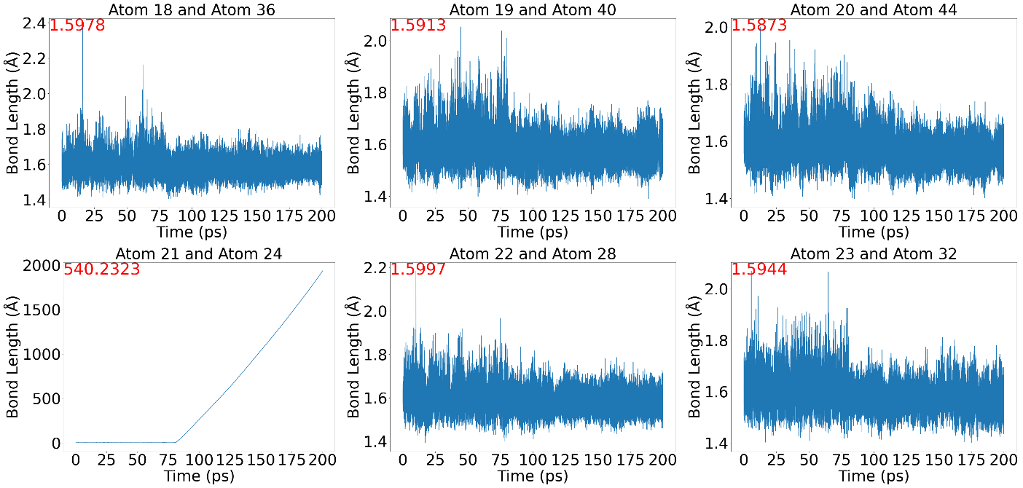

700 K

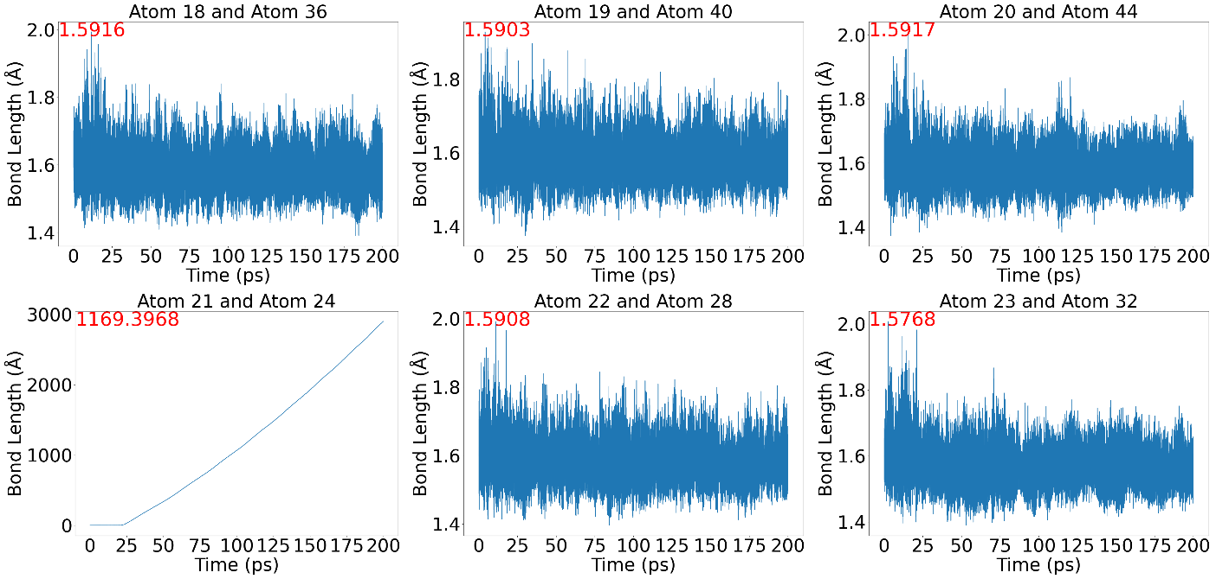

800 K

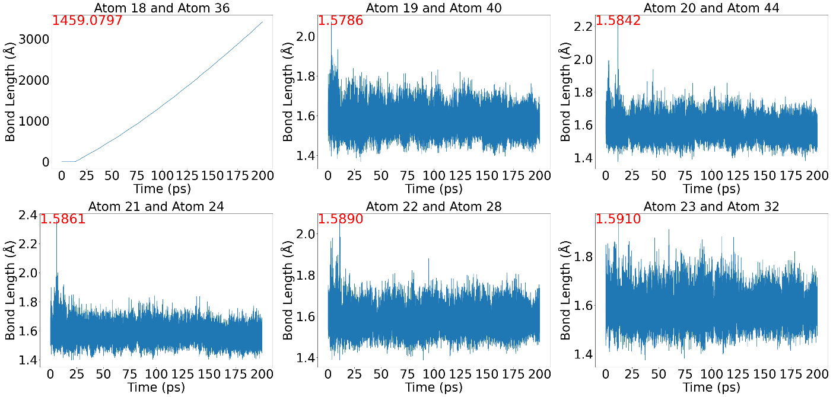

900 K

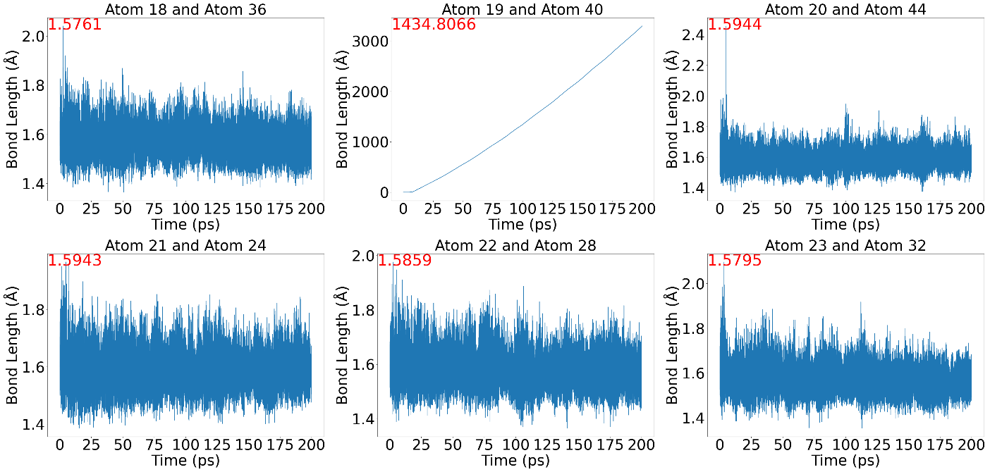

Zn(MA)2(TFA)4_a

300 K

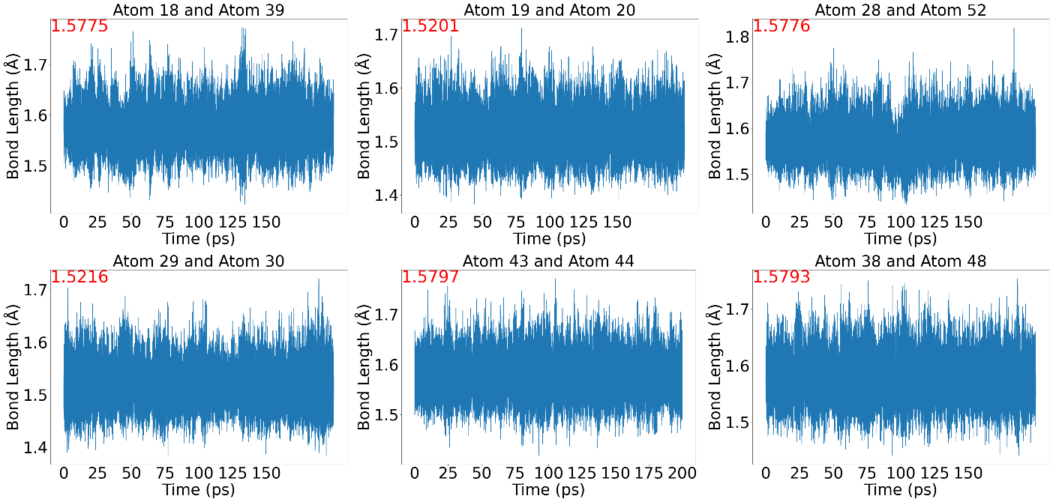

400 K

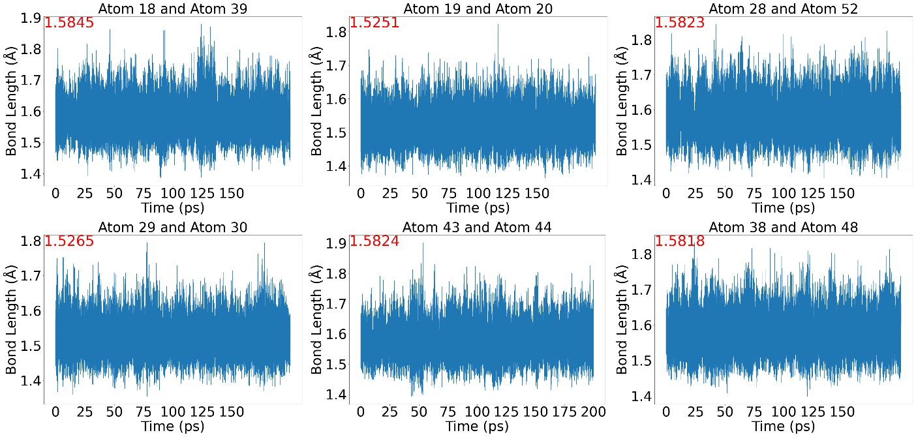

500 K

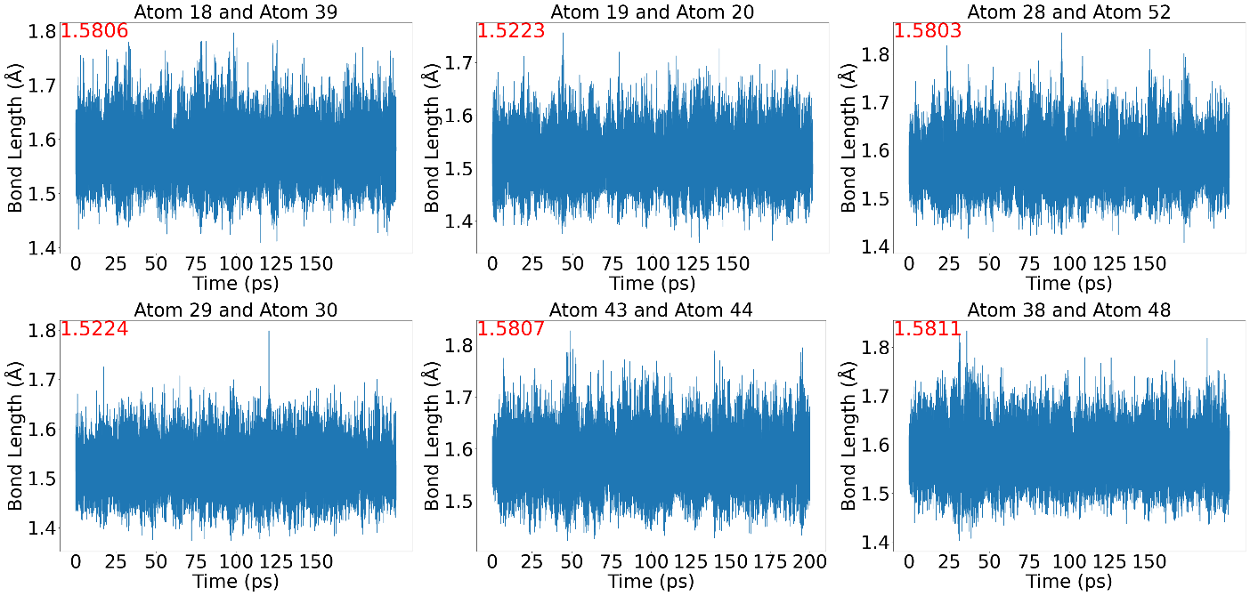

600 K

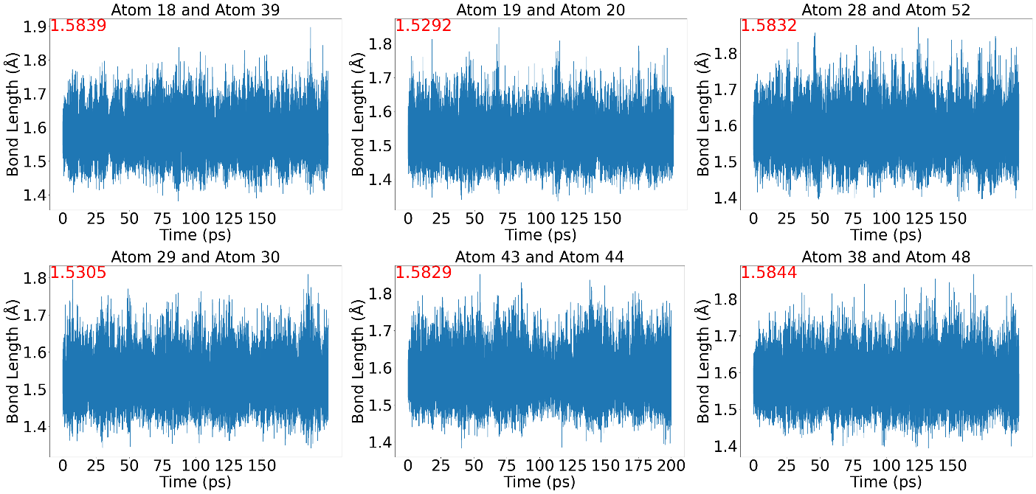

700 K

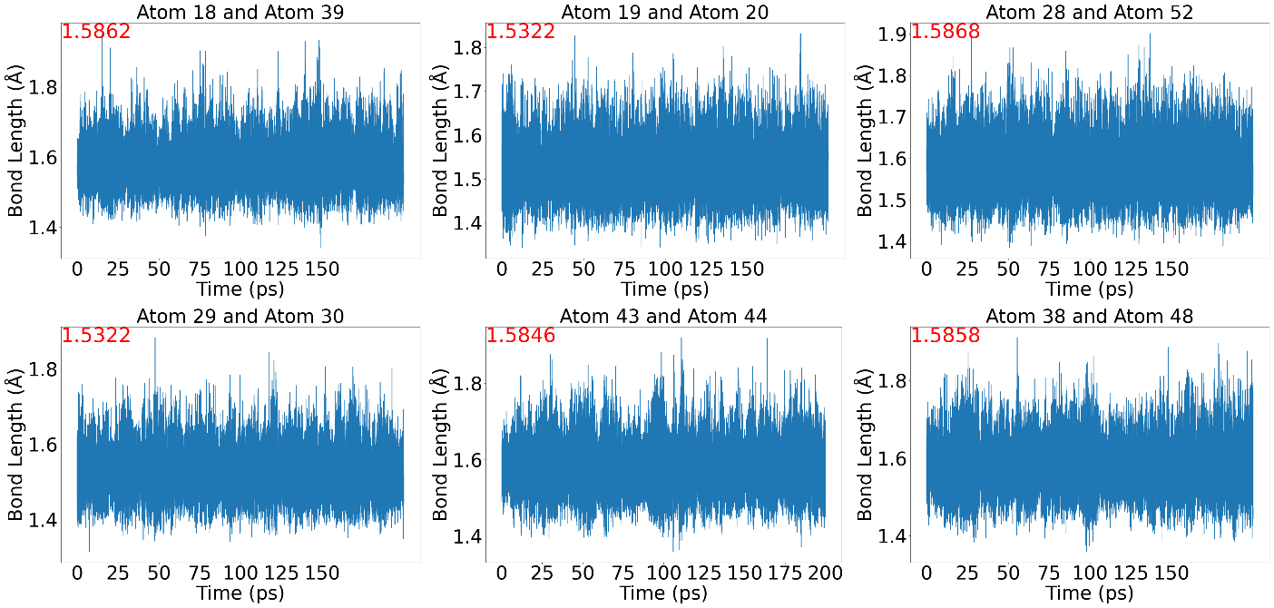

800 K

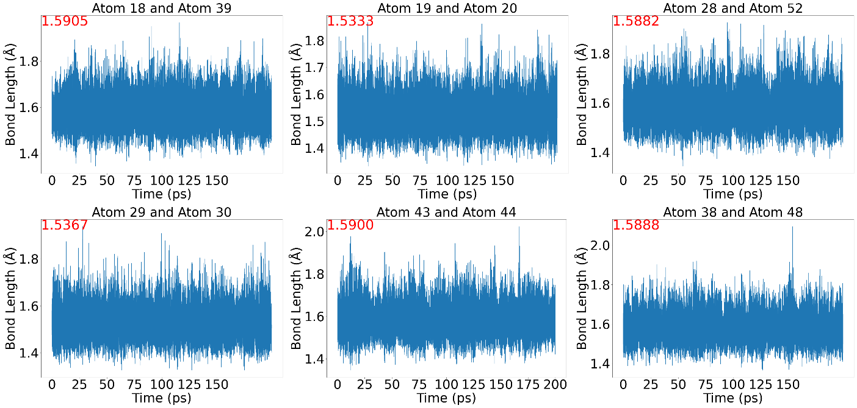

900 K

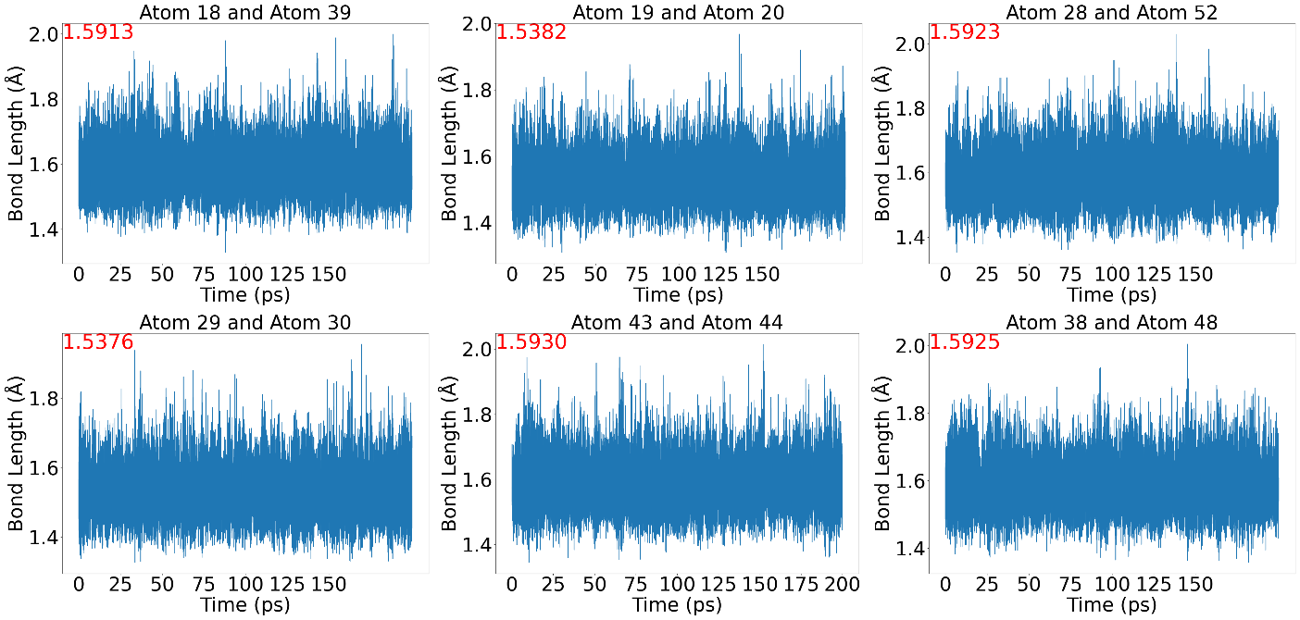

Zn(MA)6

300 K

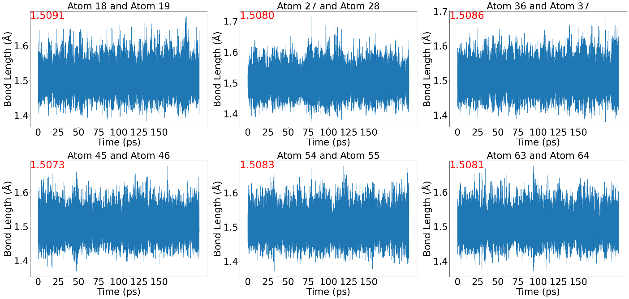

400 K

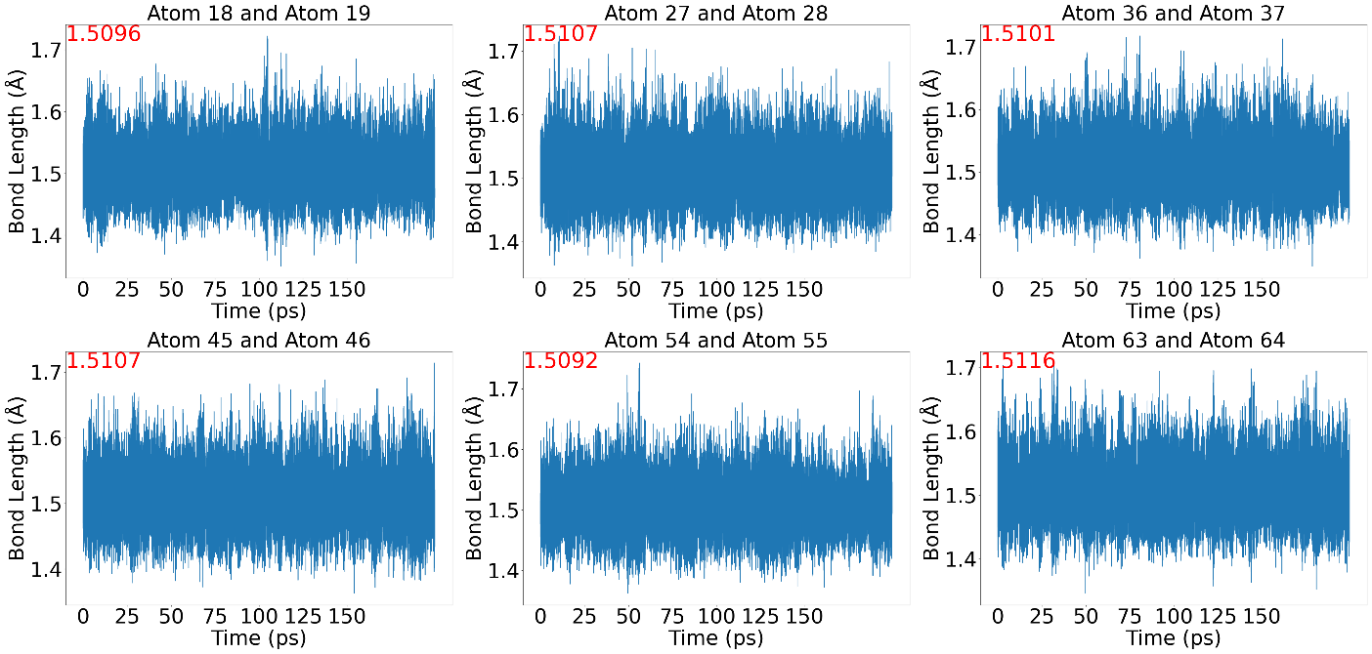

500 K

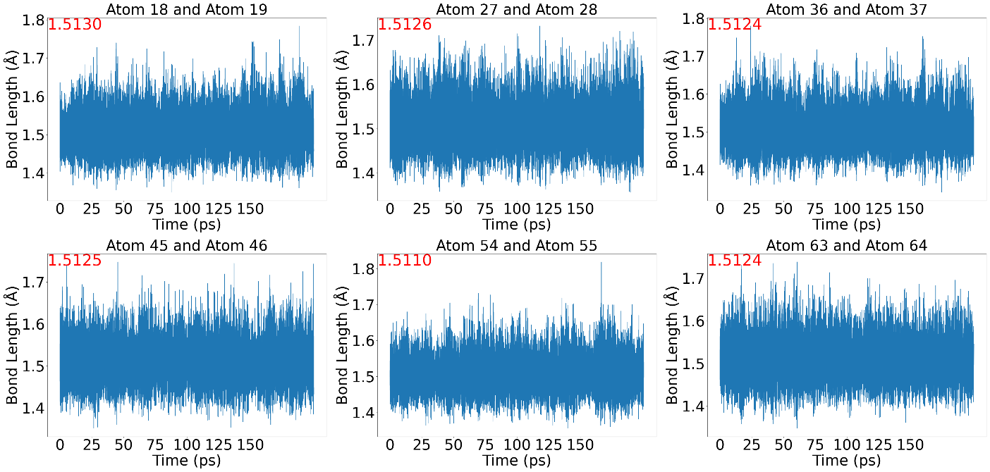

600 K

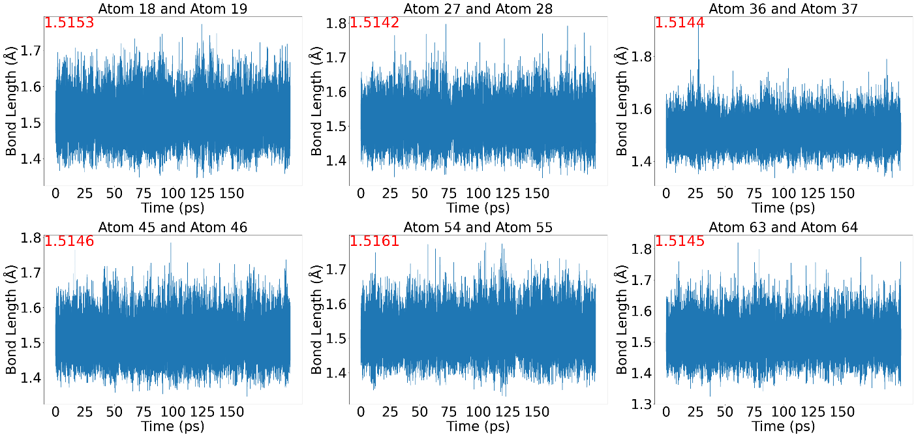

700 K

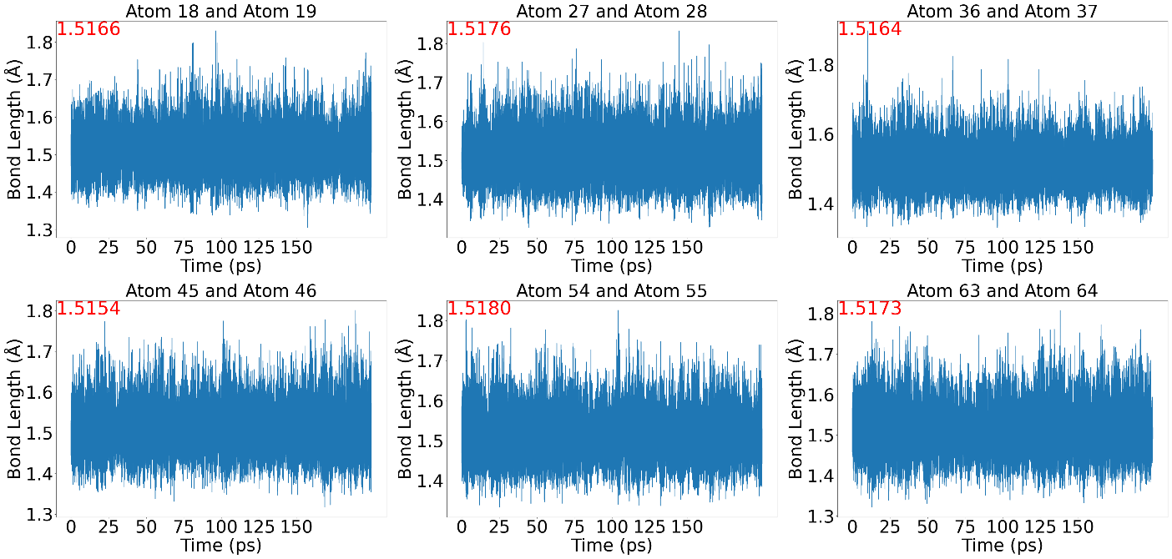

800 K

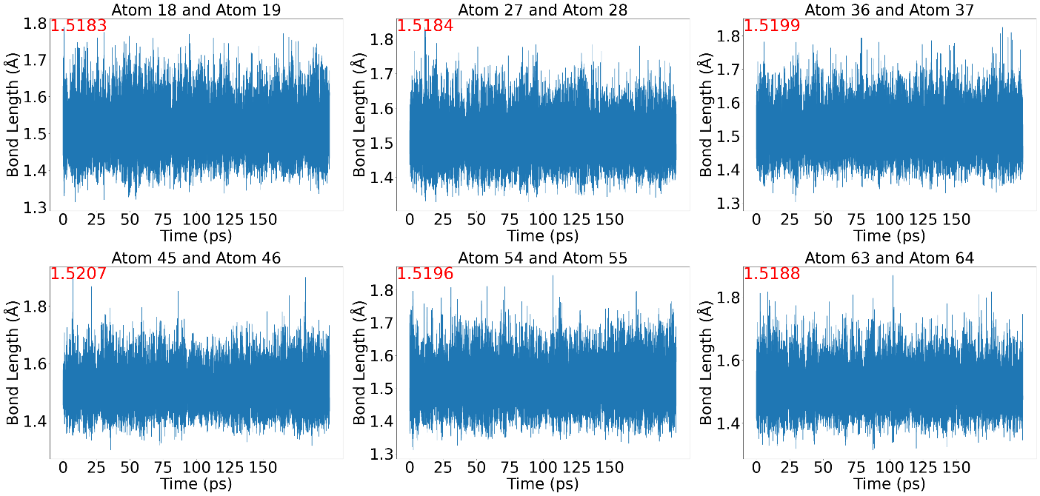

900 K

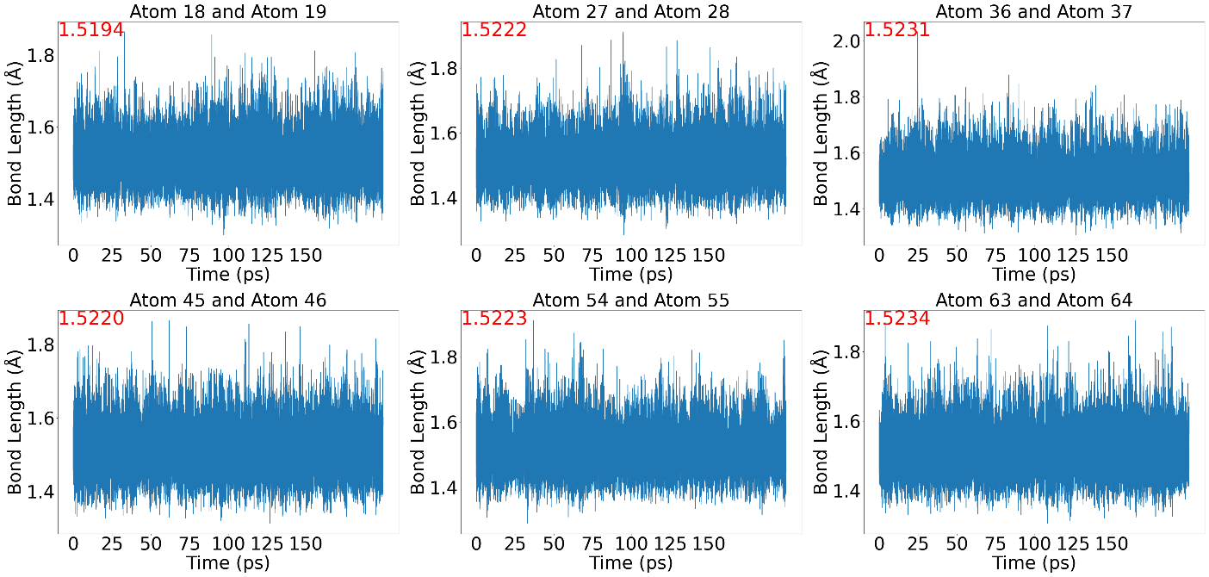

1000 K

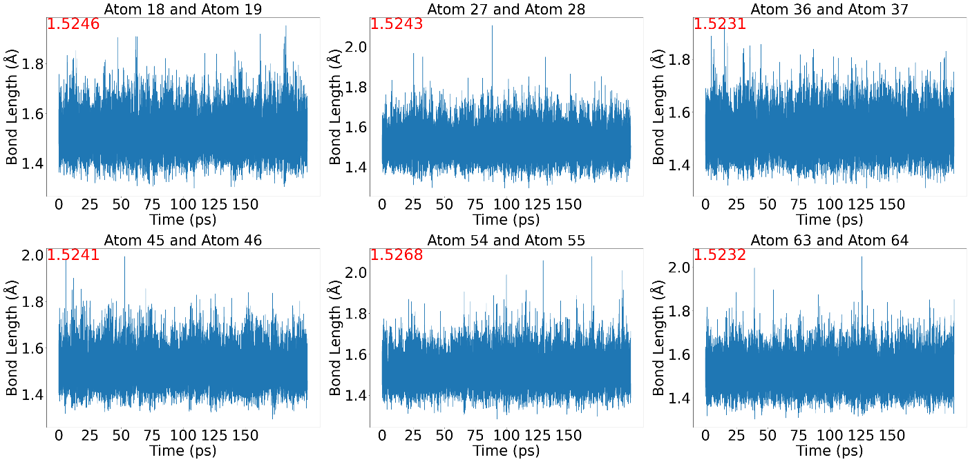

1100 K

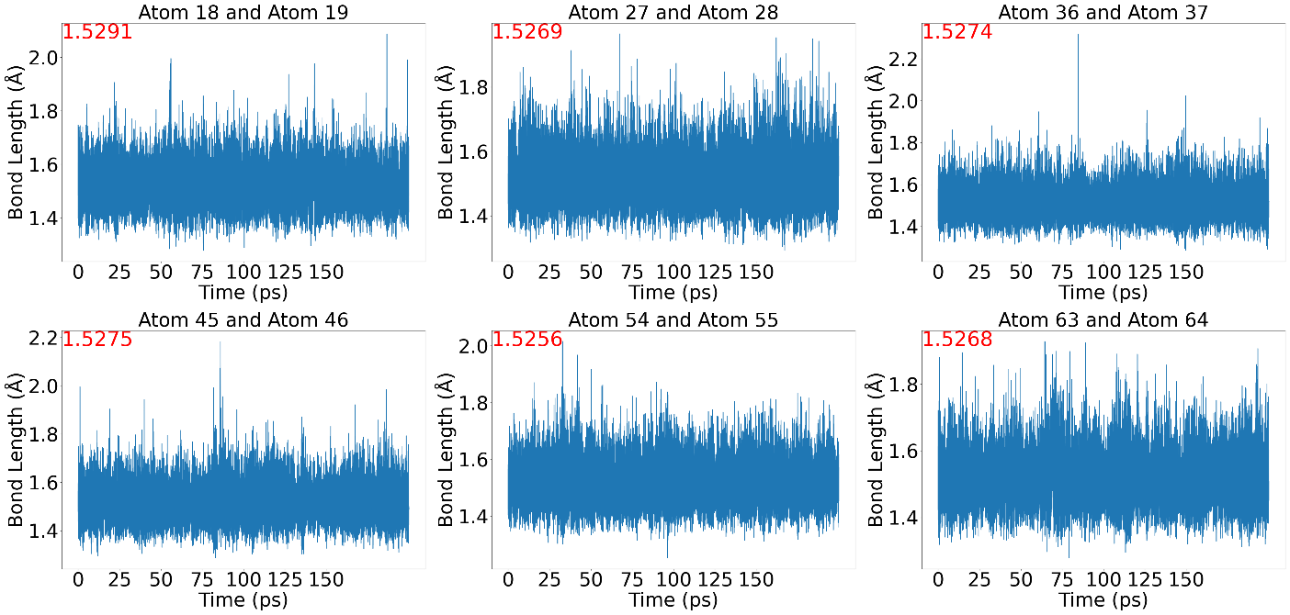

1200 K

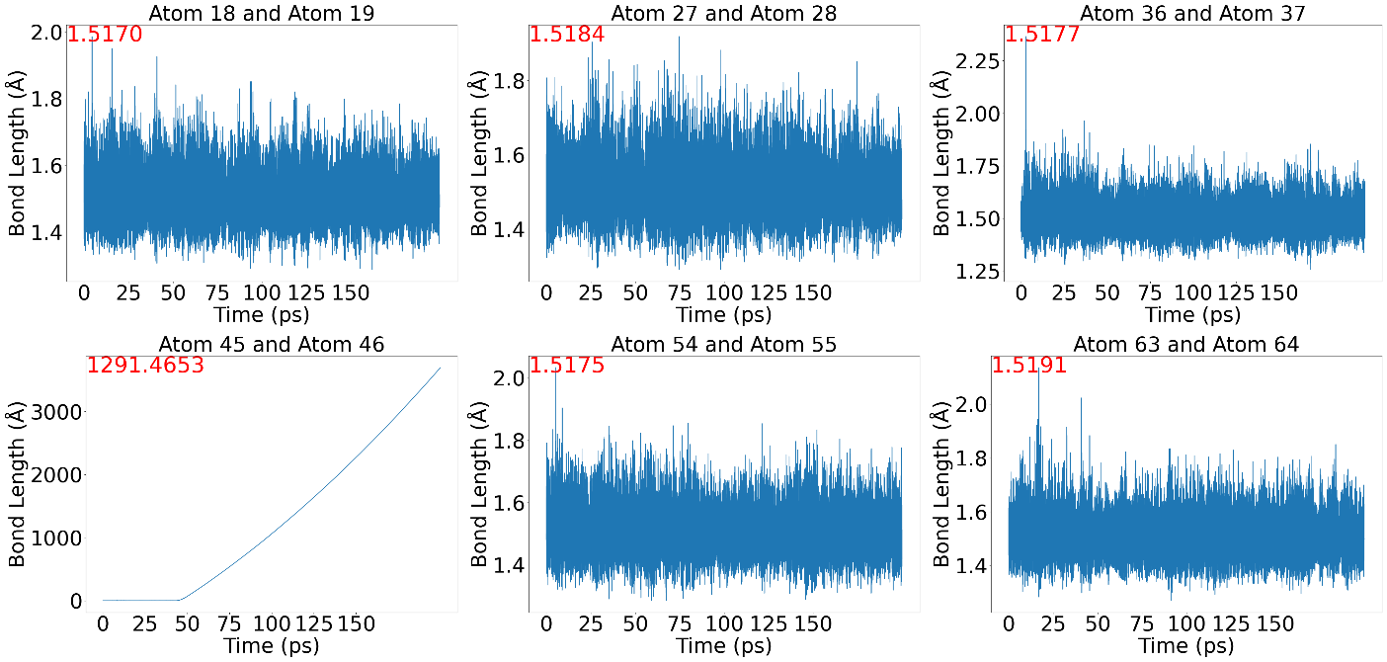

Fig. S4 The evolution of C-C bond length with time at different temperatures (from 300 to 900 K, the temperature was extended to 1200 K for Zn(MA)6). The red font in the individual picture shows the mean value of C-C bond length in 200 ps.



Fig. S5 The difference in Gibbs free energy for compounds (with different ratio of MA and TFA) in diverse solvents and at various temperatures.